**Stage – 1**

**Chinese Checkers in Python**

**Introduction: Chinese checkers** is a strategy board game of German origin which can be played by two, three, four, or six people, playing individually or with partners. The objective is to be first to race all of one's pieces across the hexagram -shaped board into "home"—the corner of the star opposite one's starting corner—using single-step moves or moves that jump over other pieces. The remaining players continue the game to establish second-, third-, fourth-, fifth-, and last-place finishers. The aim is to race all one's pieces into the star corner on the opposite side of the board before opponents do the same. The destination corner is called *home*. Each player has 10 pieces.

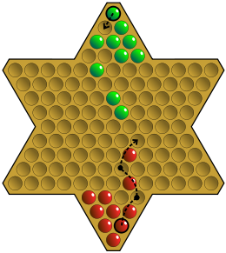

**Implementation:** This board game will be implemented in python language. The **GUI** of the game will be created with the help of modules in python namely tkinter and turtle. Tkinter is a Python binding to the Tk GUI toolkit. It is the standard Python interface to the Tk GUI toolkit, and is Python's de facto standard GUI. Tkinter is included with standard Linux, Microsoft Windows and Mac OS X installs of Python. The backend work will also be done in python only with the help of various modules and functions .

**Requirements:** 1. Python 3.0

**Possible changes:** There may be changes in the shape of the board and the game at first would be made for two players.

Submitted By: Sushant Sharma

Roll No: 16csu380